**Analyst Engineer Challenge – ADDI**

**DATA MART**

A partir de las 3 tablas CSV, se procede a crear el modelo conceptual.

Se detectan diferentes atributos que componen la información:

* Client
* Application
* Loan
* Product
* Time
* Ally
* Journey Name
* Journey Stage
* Client Type

Modelo Lógico:

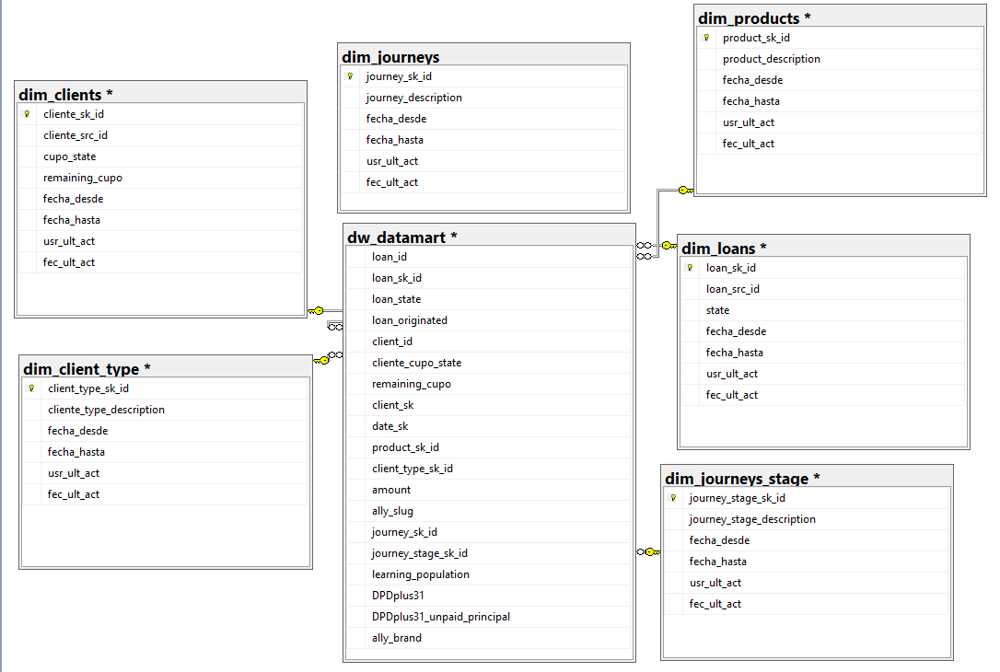

Los scripts deben correrse en orden por número:

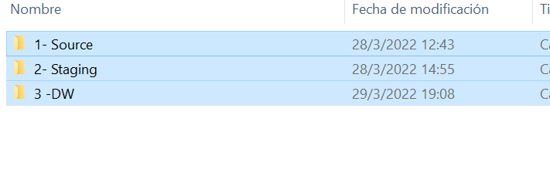

Y dentro de cada carpeta, por orden numérico también:



El modelo contiene una capa de Source, donde se encuentran los orígenes csv pasados a tablas y vistas. Luego, una Capa de Staging, a la cual llegan transformados, y con una clave subrogada (SK el caso de las Dimensiones). Esto, último, para preveer a futuro una metodología Slow Changing Dimension.

Finalmente, se encuentra la capa VW, donde se disponibilizan las tablas DIM, y el Data Mart.

**METRICS:**

1. Using the datamart, calculate 2 metrics: ○ Conversion: ratio between quantity of loans (nominator) and the count of raw where journey_stage_name='loan-acceptance-co'. Note: this metric is not a simple sum, the combination of date, client, ally and journey (d_vintage, prospect_id, ally_slug, journey_name) counts like 1.

with l as(

select count(loan_id) as loans from [DB_DW].[dbo].[dw_datamart]

where loan_id <> '-1'),

cant as (

select count(a.date_sk) as cantidad from(

select a.date_sk, a.client_sk, a.ally_slug, a.journey_sk_id

from [DB_DW].[dbo].[dw_datamart] a

WHERE

a.client_sk <> -1 AND

a.ally_slug <> -1

AND a.journey_sk_id <> -1

AND a.journey_stage_sk_id = 9

group by a.date_sk, a.client_sk, a.ally_slug, a.journey_sk_id) as a)

select convert(float,l.loans)/convert(float,cant.cantidad)/10 from l, cant

RESULTADO = 0,763941940412529

1. Active Users: an active user is a user that has gotten at least 1 loan (and it was not cancelled).

select count(distinct A.client_sk) from [DB_DW].[dbo].[dw_datamart] A

INNER JOIN [DB_DW].[dbo].[dim_clients] C ON A.client_sk = C.cliente_sk_id and C.fecha_hasta is NULL

where exists

(SELECT 1 FROM [DB_DW].[dbo].[dw_datamart] B where A.client_sk = B.client_sk and

loan_sk_id <> '-1' and cliente_cupo_state NOT IN ('CANCELLED_BY_ALLY', 'CANCELLED_BY_FRAUD'))

RESULTADO = 629